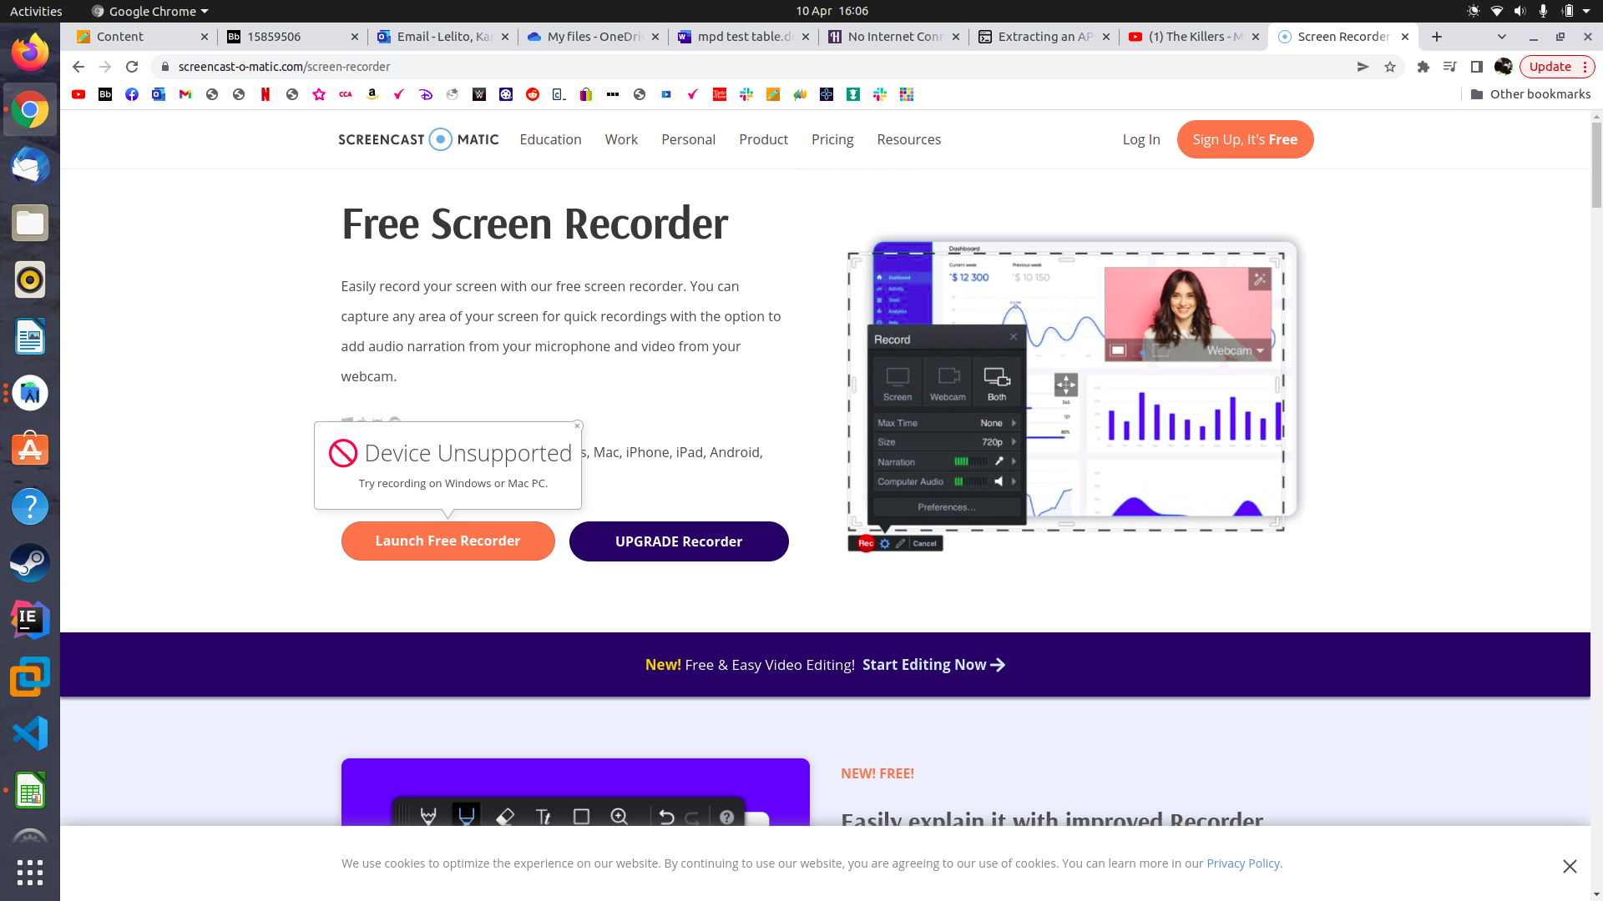

I was not able to use the outlined recording site for the application since it does not work on my laptop. I still recorded and produced an .mp4 file. I hope I do not lose marks for something out of my control.

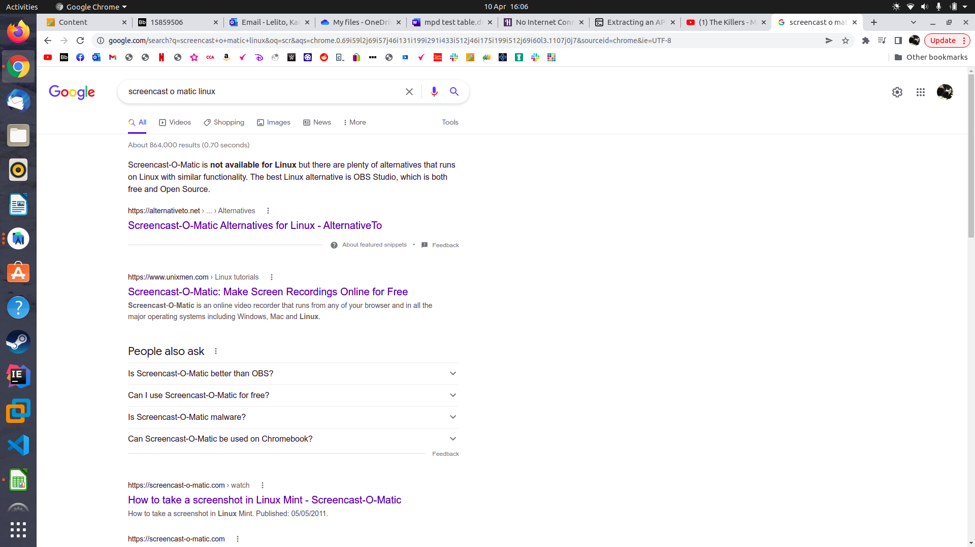

**All code, video and .apk in this one git repository**

<https://github.com/karolinalelito-stack/newTest.git>

|  |  |  |  |
| --- | --- | --- | --- |
| Test | Expected Result | Actual Result | Evidence |
| Display Data (Portrait) - current incidents | When the button is clicked then current incident info should appear | Current incident data displays correctly |  |
| Display Data (Portrait) - roadworks | When the button is clicked then roadwork info should appear | Roadworks data displays correctly |  |
| Display Data (Portrait) - planned roadworks | When the button is clicked then planned roadwork info should appear | Planned roadworks data displays correctly |  |
| Display Data (Landscape) - current incidents | When the button is clicked then current incident info should appear neatly in landscape view | Current incident data displays correctly in landscape view |  |
| Display Data (Landscape) - roadworks | When the button is clicked then roadwork info should appear neatly in landscape view | Roadwork data displays correctly in landscape view |  |
| Display Data (Landscape) - planned roadworks | When the button is clicked then planned roadwork info should appear neatly in landscape view | Planned roadwork data displays correctly in landscape view |  |
| Navigate (Portrait) - Go to current incidents | Easily navigate to current incidents data by clicking correct button | Button easily found on main/home page |  |
| Navigate (Portrait) - Go to roadworks | Easily navigate to roadwork data by clicking correct button | Button easily found on main/home page |  |
| Navigate (Portrait) - Go to planned roadworks | Easily navigate to planned roadwork data by clicking correct button | Button easily found on main/home page |  |
| Navigate (Landscape) - Go to current incidents | Easily navigate to current incidents data by clicking correct button in landscape view | Button easily found on landscape main/home page |  |
| Navigate (Landscape) - Go to roadworks | Easily navigate to roadwork data by clicking correct button in landscape view | Button easily found on landscape main/home page |  |
| Navigate (Landscape) - Go to planned roadworks | Easily navigate to planned roadwork data by clicking correct button in landscape view | Button easily found on landscape main/home page |  |
| Functionality (Portrait) - display current incident details | All details about current incidents displayed correctly I.e title, description etc. | Details about current incidents correctly displayed |  |
| Functionality (Portrait) - display roadwork details | All details about roadworks displayed correctly I.e title, description etc. | Details about roadworks correctly displayed |  |
| Functionality (Portrait) - display planned roadwork details | All details about planned roadworks displayed correctly I.e title, description etc. | Details about planned roadworks correctly displayed |  |
| Functionality (Portrait) - select date for current incident details | (example date : 14 Apr) all incidents for chosen date displayed | n/a since it doesn’t provide dates |  |
| Functionality (Portrait) - select date for roadworks details | (example date : 14 Apr) all roadworks for chosen date displayed | All roadworks happening during that date are displayed |  |
| Functionality (Portrait) - select date for planned roadwork details | (example date : 14 Apr) all planned roadworks for chosen date displayed | All planned roadworks happening during that date are displayed |  |
| Functionality (Portrait) - see colour representation | Green colour for short delays, amber for medium and red for long | Not implemented |  |
| Functionality (Portrait) - search function for current incidents | (example search: m8) all incidents for search displayed correctly | All incidents on roads starting with m8 are displayed |  |
| Functionality (Portrait) - search function for roadworks | (example search: m8) all roadworks for search displayed correctly | All roadworks on roads starting with m8 are displayed |  |
| Functionality (Portrait) - search function for planned roadworks | (example search: m8) all planned roadworks for search displayed correctly | All planned roadworks on roads starting with m8 are displayed |  |
| Functionality (Landscape) - display current incident details | All details about current incidents displayed correctly I.e title, description etc. In neat landscape view | Details about current incidents correctly displayed in landscape view |  |
| Functionality (Landscape) - display roadwork details | All details about roadworks displayed correctly I.e title, description etc. In neat landscape view | Details about roadworks correctly displayed in landscape view |  |
| Functionality (Landscape) - display planned roadwork details | All details about planned roadworks displayed correctly I.e title, description etc. In neat landscape view | Details about planned roadworks correctly displayed in landscape view |  |
| Functionality (Landscape) - select date for current incident details | (example date : 14 Apr) all incidents for chosen date displayed in neat landscape view | n/a since it doesn’t provide dates |  |
| Functionality (Landscape) - select date for roadworks details | (example date : 14 Apr) all roadworks for chosen date displayed in neat landscape view | All roadworks happening during that date are displayed in landscape view |  |
| Functionality (Landscape) - select date for planned roadwork details | (example date : 14 Apr) all planned roadworks for chosen date displayed in neat landscape view | All planned roadworks happening during that date are displayed in landscape view |  |
| Functionality (Landscape) - see colour representation | Green colour for short delays, amber for medium and red for long | Not implemented |  |
| Functionality (Landscape) - search function for current incidents | (example search: m8) all incidents for search displayed correctly in neat landscape view | All incidents on roads starting with m8 are displayed in landscape view |  |
| Functionality (Landscape) - search function for roadworks | (example search: m8) all roadworks for search displayed correctly in neat landscape view | All roadworks on roads starting with m8 are displayed in landscape view |  |
| Functionality (Landscape) - search function for planned roadworks | (example search: m8) all planned roadworks for search displayed correctly in neat landscape view | All planned roadworks on roads starting with m8 are displayed in landscape view |  |
| Journey Plan (Portrait) - view roadworks on specific date | Plan to journey on 25 Apr, select date and view roadworks on that date to avoid when driving.  Info displayed accordingly |  |  |
| Journey Plan (Portrait) - view closures | Search all closures to know where to not drive when making journey. Info displayed accordingly |  |  |
| Journey Plan (Landscape) - view roadworks on specific date | Plan to journey on 25 Apr, select date and view roadworks on that date to avoid when driving.  Info displayed accordingly in neat landscape view |  |  |
| Journey Plan (Landscape) - view closures | Search all closures to know where to not drive when making journey. Info displayed accordingly in neat landscape view |  |  |
| Internet Connection lost | In the same way as google maps or other navigation app, if no internet then it shouldn’t work | Warning comes up stating no internet |  |